Workshop: Indi-Go-Modern

Presenter: David Owen Hastings
The lure of indigo is strong — the classic blue and white combination found in many Japanese textiles is cool, crisp, and so appealing.

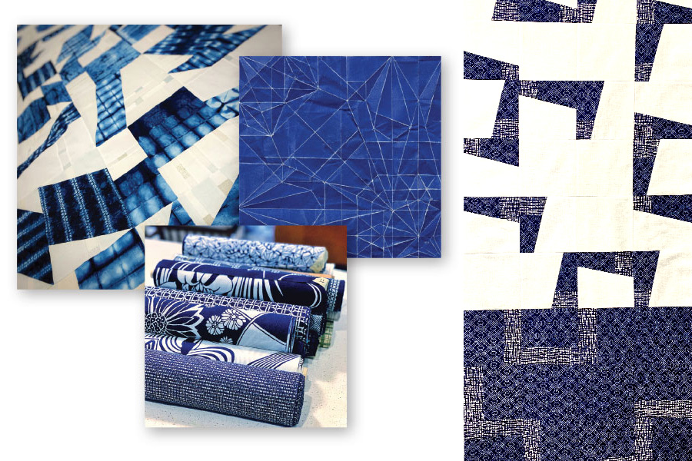

CLASSIC, COOL BLUE AND WHITE PAIRED WITH MODERN DESIGN
6 hours: From classic kimonos to denim jeans, indigo has been used by many cultures for dyeing cloth, and the Japanese have refined the use of indigo to an art form. This is the class to use all those lovely blue and white shibori fabrics you’ve dyed yourself, or use carefully curated blue and white fabrics from your stash.

Each participant will develop a simple geometric block design based on unfolded origami shapes, set a theme and create variations, and combine them into the beginning of a fresh and modern mini quilt top.

We will start out by stitching practice blocks from blue and white paper, to explore composition using minimal, modern shapes inspired by origami. A PDF will be supplied with blue and white images of fabric, which you can print at home or at a local copy center.

We’ll then translate our ideas to fabric, and I will demonstrate simple pattern making using cereal box cardboard. If you don’t have any Japanese-inspired blue and white fabric already, I recommend purchasing vintage Japanese yukata cotton fabric from OkanArts.com. Please stick to the blue and white theme. You will want to have some solid dark blues plus some whites/creams to blend with the patterned fabrics.

This workshop is a 6-hour live-stream event, conducted on Zoom, consisting of live instruction (no recording, please). You should have the current version of Zoom installed on your computer or laptop. Guidance for getting started will be sent in advance of the workshop.

ZOOM WORKSHOP DETAILS
- Look at how to take inspiration from unfolded origami paper
- Stitch some practice blocks using blue and white paper, and explore composition using your smart phone or digital camera to take photos along the way
- Keep the lines and shapes very simple and spare for a modern look
- Transfer your design to cardboard, label and cut out pattern pieces
- Select blue and white fabrics for your simple block design
- Audition fabrics for contrast, pattern, texture and placement
- Use cardboard pattern pieces to cut out fabric, leaving a generous amount of extra fabric for seam allowances
- Sew 9-12 blocks, and explore how multiple blocks interact with each other, creating new shapes
- Sew more blocks as time allows to build up a mini quilt top
- Discuss surface design options: hand stitching and machine quilting
- Watch a demo of facing a quilt for a modern look, and joining finished quilt blocks

I will provide full hands-on instructions in class. Bring blue and white fabrics, including some solids, that you would like to use. If you’ve done some indigo dyeing, or have some vintage Japanese yukata fabrics in blue and white, they will be perfect for this workshop!
This is an all-levels workshop. You should be comfortable using your sewing machine, and it should be in good working order. I look forward to sharing and sewing with you!
For more about David, please visit www.davidowenhastings.com or follow @davidowenhastings on Instagram.

